How Meta AI Works: Understanding the Backend Process

Introduction :
Meta AI is an artificial intelligence assistant created by Meta. It can answer question generate content and provide information using AI technology.
Meta AI can understand and process various types of information, including:
- Text
- Images
- Audio
- Videos
It is designed to assist users with:
- Provide answer to question
- Creating content
- Support in education
- Generate Summaries
- Solve every type problem

Where is Meta AI Used ?

Meta AI is used as an intelligent digital assistant
- Answering question
- Generate images
- Research tools
- In WhatsApp to answer question
- In instagram for recommendations

~ Backend Workflow: How Meta AI Processes a User Prompt

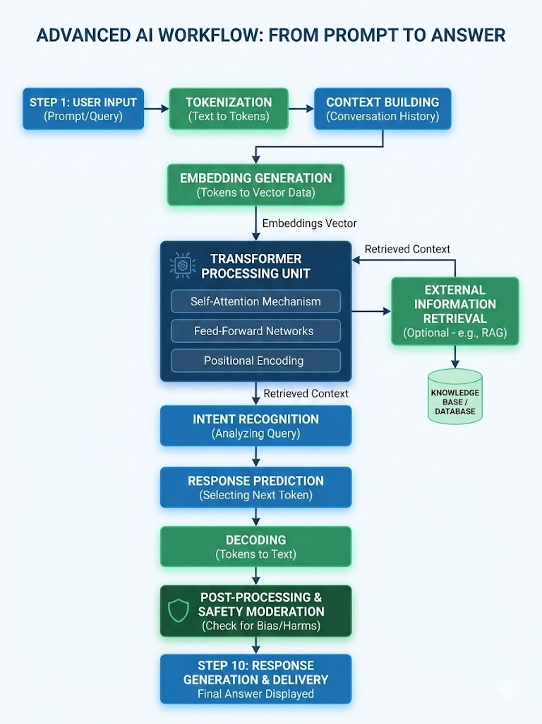

Step 1: User Input
The process begins when a user enters a prompt, question, command, image, or voice message.
Example:
"What are the best places to visit in Japan?"
The user's request is securely transmitted from the application to Meta's servers.

Step 2: Tokenization
Computers cannot directly understand human language.
The input text is divided into smaller units called tokens.
Example:
"What are the best places to visit in Japan?"
may become:
["What", "are", "the", "best", "places", "to", "visit", "in", "Japan", "?"]

Step 3: Context Building
Meta AI does not process only the latest message. It collects additional information such as:
- Recent conversation history
- User preferences
- Language settings
- Application context
- System instructions
This information helps the model generate more accurate and relevant responses.

Step 4: Embedding Generation
Each token is converted into a numerical representation called an embedding.
Embeddings help the model understand:
- Word meanings
- Relationships between words
- Contextual information

Words with similar meanings have similar embedding vectors

Step 5: Transformer Processing
This is the core intelligence layer of Meta AI.
The transformer architecture uses self-attention mechanisms to understand relationships between tokens.

~ It uses three key components :-
- Self-Attention Mechanism:- It help the AI connect words with each other to understand the true meaning
- Feed-forward networks :- It processes the data through math layer to prepare the system for finding the correct answer
- Positional encoding :- it adds a mathematical tag to each word to tell the position of words in the sentence

Step 6: Intent Recognition and Request Routing
Meta AI analyzes the user's prompt to determine:
- User intent
- Task type
- Required tools
- Complexity level
Depending on the request, the system may route it to different services.
Examples:
- General questions → Language model
- Current events → Search system
- Image generation → Image model

Translation → Translation service

Step 7:External Information Retrieval (Optional/RAG)
If the request requires current or external information, Meta AI may use Retrieval-Augmented Generation (RAG).
The process includes:
- Converting the query into embeddings
- Searching internal knowledge bases
- Accessing approved external sources
- Retrieving relevant information

The retrieved data is added to the model's context

Step 8: Response Prediction
After processing the input, the model predicts the most probable next token.
Example:
Input:
"Machine learning is a branch of"
Possible predictions:
Word | Probability
Artificial Intelligence | 75%
Computer Science | 15%
Mathematics | 7%
Engineering | 3%
The model selects the most suitable token and repeats the process until the response is complete.

Step 9: Decoding
The predicted tokens are converted into readable text.
Common decoding methods include:
- Greedy Decoding
- Beam Search
- Sampling

This stage influences the creativity, diversity, and style of the generated response

Step 10:Post-Processing & Safety Moderation
The generated response passes through additional safety systems that check for:
- Harmful content
- Policy violations
- Sensitive information
- Inappropriate responses

If necessary, the response may be modified, filtered, or regenerated

Step 11: Response Generation and Delivery
The approved response is formatted and streamed back to the user.
The output may include:
- Answers
- Explanations
- Summaries
- Recommendations
- Generated content
The user receives the response in real time.

. ~ What is the feature of Meta AI :-
- Natural Language understanding
- Content creation
- Education support
- Image creation
- Multimodal processing

Unique Features of Meta AI
- Multimodal capabilities
- Natural language understanding
- Real-time assistance
- Fast response generation
- Integration with Meta applications
- Support for multiple languages
- Content creation capabilities
- Coding assistance

Real world Applications

Education
- Personalized learning
- Concept explanations
- Research assistance

Content Creation
- Blog writing
- Social media content
- Summarization

Programming
- Code generation
- Debugging support
- Technical guidance

Business
- Customer support
- Documentation
- Productivity assistance

Limitations of Meta AI
- Responses may occasionally contain errors
- Depends on the quality of user prompts
- May require external information for current events
- Cannot replace human judgment completely
- Exact backend implementation details are proprietary

Conclusion:

Meta AI combines large language models, retrieval systems, transformer architectures, and safety mechanisms to provide intelligent assistance across Meta's platforms. By integrating advanced AI capabilities into everyday applications, Meta AI enables users to access information, solve problems, and create content more efficiently.

.

